**Veloxn Pvt Ltd Date Wise Social Posting Plan**

**Date – 6 Oct 2025**

Following post will go at all socials as Facebook, X.Com, Instagram, linkedin, YouTube, GMB, Quora, Reddit, Medium, Pinterest, Behance / Dribbble, About.me, Clarity.fm, Meetup, Eventbrite

Text –

Media - 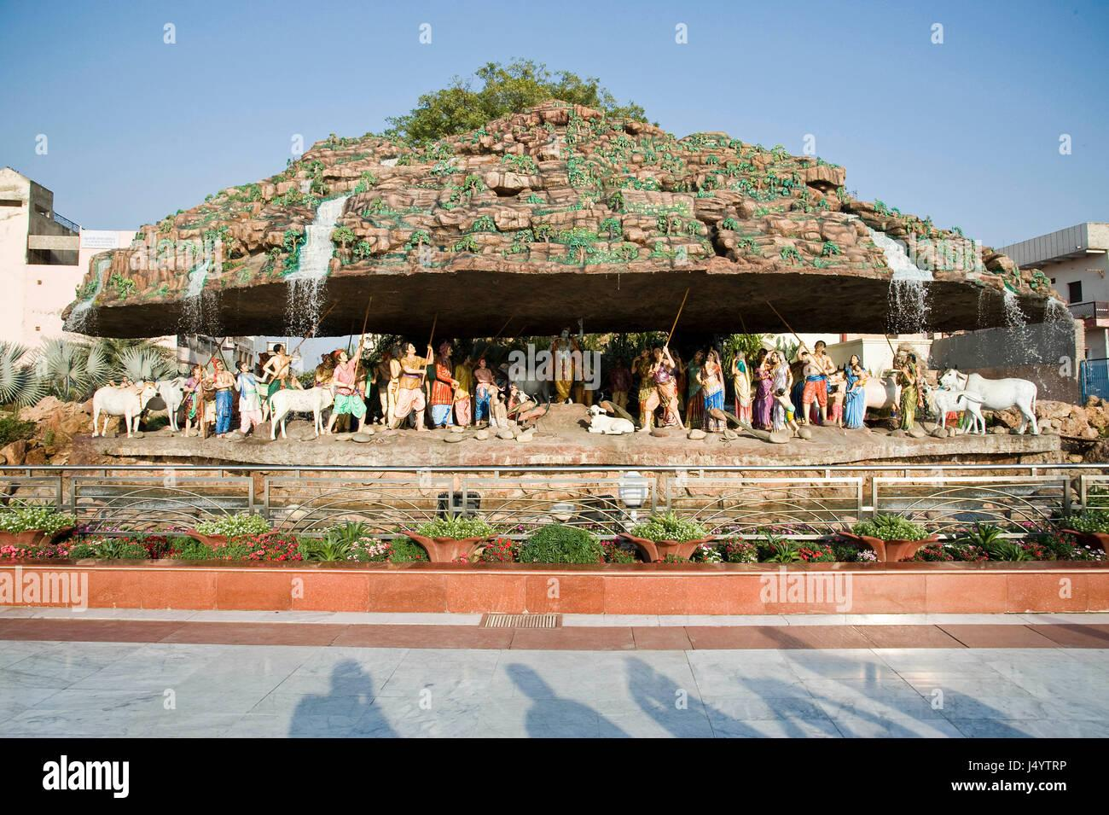

Approval Status by Mamta Ma’am - **Approved or Not Approved?**

The above blog is posted at <https://docs.google.com/document/d/1y_aaI91risz0mbxzo4C_ToRrfEqAtMTi/view>